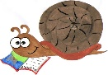

Lyng Primary School Knowledge Organiser

History Topic: | Anglo Saxons  How did the Anglo-Saxons live? | Year 4  Buildings, Battles and Beliefs | Autumn

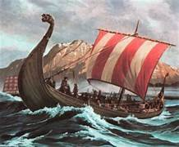

Spelling | Definition
Angles | people from Germany who invaded Britain around AD 410
Anglo-Saxon | the name given to the people who travelled from Germany and South Denmark and settled in Britain around AD 410
Archaeologist | someone who studies the past by exploring old remains
Artefact | an object from the past that shows evidence of what life was like
Century | a period of 100 years
Christianity | the region based on the teachings of Jesus Christ
Invasion | to try and take over a place by force
Jutes | people from the Jutland peninsula (Germany and Southern Denmark) who invaded Britain around AD 410
Migration | movement from one place to another in order to settle there
Monk | a member of a male religious community
Picts | ancient tribes who lived in northern Scotland
Pagan | a person who follows a religion that is not a major religion, including Christianity, Islam, Judaism, Buddhism, Hinduism, and Sikhism
Saxons | people from northern and central Germany who invaded Britain around AD 410
Scots | people from Ireland who eventually settled in Scotland
Settler | people who migrate to a new place.

Let’s recap…
- Year 1 – Children learn about what an explorer is and how significant they are to learn about our past.
- Year 2 – Children begin to use a range of sources to compare evidence in history.
- Year 3 – Children learn how the Romans named key places in Britain (including roads)


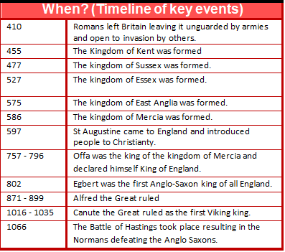
HOOK - Magnus’ Mystery
A letter from Magnus found in the forest – he requires the children to create a weapon for his travels to Northumbria.
TRIP/VISITOR
Anglo-Saxon Visitor - September

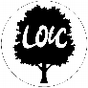
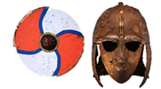
To discover more:
BBC Bitesize - Anglo-Saxons https://www.bbc.co.uk/bitesize/topics/zxsbcdm
Britannica Kids – Anglo-Saxons https://kids.britannica.com/kids/article/Anglo-Saxon/352755

Our Storytelling Approach to enhance engagement

People:  Magnus (Anglo-Saxon Boy) | Place:  Northumbria | Problem:  Magnus must prepare for a potential battle in the North – will it be for or against his uncle?
Focus Text

The Anglo-Saxons came to England after the Romans left in the year 410. Nobody was really ruling all of England at the time – there were a lot of little kingdoms ruled by Anglo-Saxons that eventually came together as one country.
The earliest English kings were Anglo-Saxons, starting with Egbert in the year 802. Anglo-Saxons ruled for about three centuries, and during this time they formed the basis for the English monarchy and laws. The two most famous Anglo-Saxon kings are Alfred the Great and Canute the Great.
The Anglo-Saxons are made up of three tribes who came to England from across the North Sea around the middle of the 5th century – the Angles, Saxons, and Jutes.
Egbert was the first Anglo-Saxon king to rule England. The last Anglo-Saxon king was Harold II in 1066.
The Anglo-Saxon period covers about 600 years, and Anglo-Saxon kings ruled England for about 300 years.

Key Facts and Famous Figures
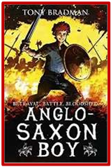

Enquiry questions (sequence of learning) that we shall investigate during the topic:
- When did the Anglo-Saxons arrive in Britain?
- How did the Anglo-Saxons communicate?
- Were Anglo-Saxon houses purposeful?
- What were the beliefs of Anglo-Saxons?
Agreed Outcome
A recount detailing the events of our Anglo-Saxon visitor (English link)

Lyng Primary School Knowledge Quiz

History Topic: | Anglo Saxons  How did the Anglo-Saxons live? | Year 4  Buildings, Battles and Beliefs | Autumn
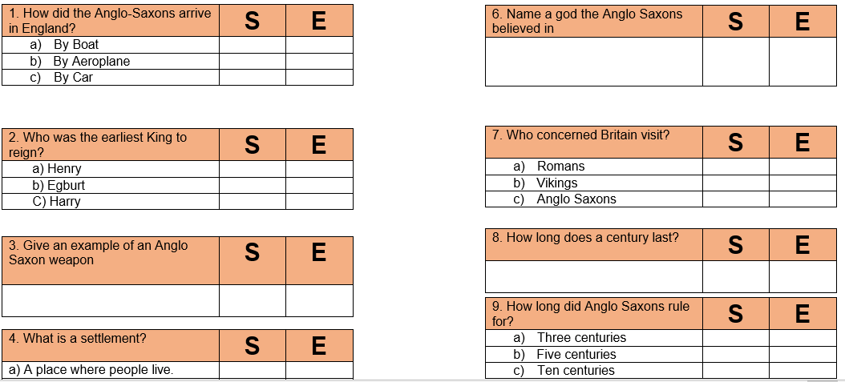

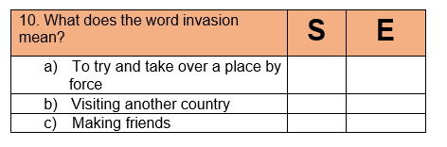
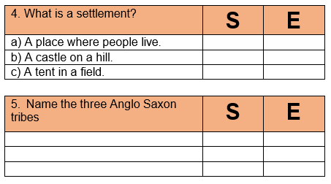
Our Anglo-Saxon
Quick Quiz

